Amazon E-commerce Services

MIS 381N – Information Management – Fall 2022

Final Project

December 7th, 2022

Group Members:

Kshitij Mahajan (ksm3267)

Saurabh Arora(sa55445)

Vivek Dhulipalla(vd6543)

Olivia Lee(rl29986)

Aidan Cremins(amc8738)

**Section 1 - Data Models for Transactions:**

1. **Order Processing**

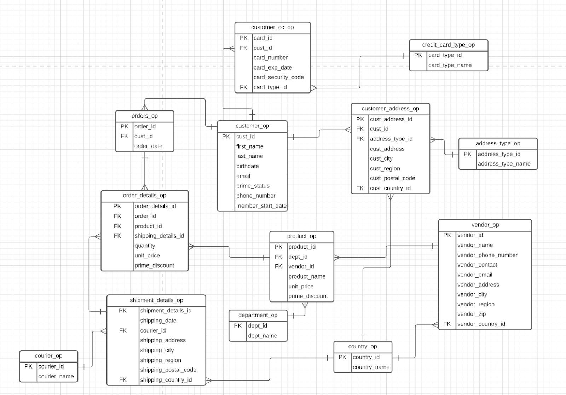

**2.Call Center Operations**

**3. Inventory Management**

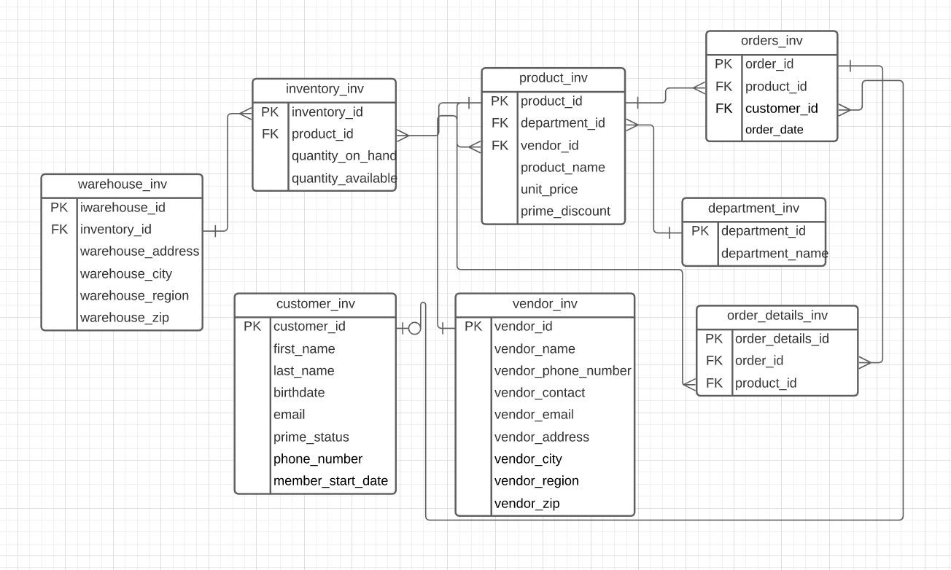

**4.Data Warehouse**​

**Section 2 - DDL and Inserts:**

**Order Processing DDL:**

DROP TABLE PRODUCT_OP CASCADE CONSTRAINTS;

DROP TABLE VENDOR_OP CASCADE CONSTRAINTS;

DROP TABLE CREDIT_CARD_TYPE_OP CASCADE CONSTRAINTS;

DROP TABLE SHIPMENT_DETAILS_OP CASCADE CONSTRAINTS;

DROP TABLE COUNTRY_OP CASCADE CONSTRAINTS; DROP TABLE COURIER_OP CASCADE CONSTRAINTS;

DROP TABLE CUSTOMER_CC_OP CASCADE CONSTRAINTS;

DROP TABLE department_OP CASCADE CONSTRAINTS;

DROP TABLE order_details_OP CASCADE CONSTRAINTS;

DROP TABLE customer_address_OP CASCADE CONSTRAINTS;

DROP TABLE address_type_OP CASCADE CONSTRAINTS;

DROP TABLE orders_OP CASCADE CONSTRAINTS;

DROP TABLE customer_OP CASCADE CONSTRAINTS;

CREATE TABLE address_type_op ( address_type_id NUMBER(20) NOT NULL, address_type_name VARCHAR2(50) NOT NULL,

PRIMARY KEY (address_type_id)

);

CREATE TABLE country_op ( country_id NUMBER(20) NOT NULL, country_name VARCHAR2(50) NOT NULL,

PRIMARY KEY (country_id)

);

CREATE TABLE department_op ( dept_id NUMBER(20) NOT NULL, dept_name VARCHAR2(50) NOT NULL,

PRIMARY KEY (dept_id)

);

CREATE TABLE courier_op ( courier_id NUMBER(20) NOT NULL, courier_name VARCHAR2(50) NOT NULL, PRIMARY KEY (courier_id)

);

CREATE TABLE credit_card_type_op ( card_type_id NUMBER(20) NOT NULL, card_type_name VARCHAR2(50) NOT NULL,

PRIMARY KEY (card_type_id)

);

CREATE TABLE customer_op ( cust_id NUMBER(20) NOT NULL, first_name VARCHAR2(50) NOT NULL, last_name VARCHAR2(50) NOT NULL, birthdate DATE NOT NULL, email VARCHAR2(50) UNIQUE NOT NULL, prime_status VARCHAR2(1) DEFAULT 'N' NOT NULL, systemdate DATE DEFAULT SYSDATE NOT NULL, phone_number VARCHAR2(50), member_start_date DATE,

PRIMARY KEY (cust_id)

);

CREATE TABLE customer_address_op ( cust_address_id NUMBER (20) NOT NULL, cust_id NUMBER (20) NOT NULL, address_type_id NUMBER(20) NOT NULL, cust_address VARCHAR2(50) NOT NULL, cust_city VARCHAR2(50) NOT NULL, cust_region VARCHAR2(50), cust_postal_code NUMBER (20) NOT NULL, cust_country_id NUMBER(10) NOT NULL,

PRIMARY KEY (cust_address_id),

CONSTRAINT FK_CUSTADD_CUSTOMER FOREIGN KEY (cust_id) REFERENCES

CUSTOMER_op(cust_id),

CONSTRAINT FK_CUSTADD_ADDRTYPE FOREIGN KEY (address_type_id) REFERENCES

ADDRESS_TYPE_op(address_type_id),

CONSTRAINT FK_CUSTADD_COUNTRY FOREIGN KEY (cust_country_id) REFERENCES COUNTRY_op(country_id)

);

CREATE TABLE customer_cc_op ( card_id NUMBER (20) NOT NULL, cust_id NUMBER (20) NOT NULL, card_number NUMBER (20) NOT NULL, card_exp_date DATE NOT NULL, card_security_code NUMBER (20) NOT NULL, card_type_id NUMBER(20) NOT NULL,

PRIMARY KEY (card_id),

CONSTRAINT FK_CC_CUSTOMER FOREIGN KEY (cust_id) REFERENCES

CUSTOMER_op(cust_id),

CONSTRAINT FK_CC_CARDTYPE FOREIGN KEY (card_type_id) REFERENCES credit_card_type_op(card_type_id)

);

CREATE TABLE vendor_op ( vendor_id NUMBER(20) NOT NULL, vendor_name VARCHAR2(50) NOT NULL, vendor_phone_number VARCHAR2(50) NOT NULL, vendor_contact VARCHAR2(50) NOT NULL, vendor_email VARCHAR2(50), vendor_address VARCHAR2(50) NOT NULL, vendor_city VARCHAR2(50) NOT NULL, vendor_region VARCHAR2(50),

vendor_zip NUMBER(20) NOT NULL, vendor_country_id NUMBER(20) NOT NULL,

PRIMARY KEY (vendor_id),

CONSTRAINT FK_VENDOR_COUNTRY FOREIGN KEY (vendor_country_id) REFERENCES COUNTRY_op(country_id)

);

CREATE TABLE product_op ( product_id NUMBER(20) NOT NULL, product_name VARCHAR2(50) NOT NULL, dept_id NUMBER(20) NOT NULL, vendor_id NUMBER(20),

UNIT_PRICE NUMBER (7,2) NOT NULL, prime_discount NUMBER(7,2),

PRIMARY KEY (product_id),

CONSTRAINT FK_PRODUCT_DEPT FOREIGN KEY (dept_id) REFERENCES

DEPARTMENT_op(dept_id),

CONSTRAINT FK_PRODUCT_VENDOR FOREIGN KEY (vendor_id) REFERENCES vendor_op(vendor_id)

);

CREATE TABLE orders_op ( order_id NUMBER(20) NOT NULL, cust_id NUMBER(20) NOT NULL, order_date DATE DEFAULT SYSDATE NOT NULL,

PRIMARY KEY (order_id),

CONSTRAINT FK_ORDERS_CUST FOREIGN KEY (cust_id) REFERENCES

CUSTOMER_op(cust_id)

);

CREATE TABLE shipment_details_op ( shipment_details_id NUMBER(20) NOT NULL, shipping_date DATE NOT NULL, courier_id NUMBER(20) NOT NULL, shipping_address VARCHAR2(50) NOT NULL, shipping_city VARCHAR2(50) NOT NULL, shipping_region VARCHAR2(50), shipping_postal_code NUMBER(20) NOT NULL, shipping_country_id NUMBER(20) NOT NULL,

PRIMARY KEY (shipment_details_id),

CONSTRAINT SHIPDETAILS_courier FOREIGN KEY (courier_id) REFERENCES courier_op(courier_id),

CONSTRAINT SHIPDETAILS_COUNTRY FOREIGN KEY (shipping_country_id)

REFERENCES COUNTRY_op(country_id)

);

CREATE TABLE order_details_op ( order_details_id NUMBER (20) NOT NULL, order_id NUMBER(20) NOT NULL, product_id NUMBER(20) NOT NULL, shipping_details_id NUMBER(20), quantity NUMBER NOT NULL, unitprice NUMBER(7,2) NOT NULL,

PRIMARY KEY (order_details_id),

CONSTRAINT FK_ORDERDET_ORDERS FOREIGN KEY (order_id) REFERENCES orders_op(order_id),

CONSTRAINT FK_ORDERDET_PRODUCT FOREIGN KEY (product_id) REFERENCES

PRODUCT_op(product_id),

CONSTRAINT FK_ORDERDET_SHIPDET FOREIGN KEY (shipping_details_id) REFERENCES shipment_details_op(shipment_details_id)

);

-- ADDRESS_TYPE TABLE

INSERT INTO "ADDRESS_TYPE_OP" (ADDRESS_TYPE_ID, ADDRESS_TYPE_NAME)

VALUES ('1', 'Billing');

INSERT INTO "ADDRESS_TYPE_OP" (ADDRESS_TYPE_ID, ADDRESS_TYPE_NAME)

VALUES ('2', 'Shipping'); commit;

-- DEPARTMENT TABLE

INSERT INTO "DEPARTMENT_OP" (DEPT_ID, DEPT_NAME) VALUES ('1', 'groccery');

INSERT INTO "DEPARTMENT_OP" (DEPT_ID, DEPT_NAME) VALUES ('2', 'books');

INSERT INTO "DEPARTMENT_OP" (DEPT_ID, DEPT_NAME) VALUES ('3', 'electronics');

INSERT INTO "DEPARTMENT_OP" (DEPT_ID, DEPT_NAME) VALUES ('4', 'wellness'); INSERT INTO "DEPARTMENT_OP" (DEPT_ID, DEPT_NAME) VALUES ('5', 'clothing'); commit;

-- COUNTRY TABLE

INSERT INTO "COUNTRY_OP" (COUNTRY_ID, COUNTRY_NAME) VALUES ('1', 'United

States');

INSERT INTO "COUNTRY_OP" (COUNTRY_ID, COUNTRY_NAME) VALUES ('2', 'China');

INSERT INTO "COUNTRY_OP" (COUNTRY_ID, COUNTRY_NAME) VALUES ('3', 'United Kingdom');

INSERT INTO "COUNTRY_OP" (COUNTRY_ID, COUNTRY_NAME) VALUES ('4', 'Australia'); INSERT INTO "COUNTRY_OP" (COUNTRY_ID, COUNTRY_NAME) VALUES ('5', 'Mexico');

commit;

-- VENDOR TABLE

INSERT INTO "VENDOR_OP" (VENDOR_ID, VENDOR_NAME, VENDOR_PHONE_NUMBER,

VENDOR_CONTACT, VENDOR_EMAIL, VENDOR_ADDRESS, VENDOR_CITY,

VENDOR_REGION, VENDOR_ZIP, VENDOR_COUNTRY_ID) VALUES ('1', 'GAP',

'214-934-0220', 'Caroline Jordan', 'cjordan@gmail.com', '123 Hut St.', 'Brookshire', 'Northwest', '76889', '4');

INSERT INTO "VENDOR_OP" (VENDOR_ID, VENDOR_NAME, VENDOR_PHONE_NUMBER,

VENDOR_CONTACT, VENDOR_EMAIL, VENDOR_ADDRESS, VENDOR_CITY,

VENDOR_REGION, VENDOR_ZIP, VENDOR_COUNTRY_ID) VALUES ('2', 'Apple', '972-972-4692', 'Sarah Holiday', 'sholiday@gmail.com', '227 Logistics Street', 'Shanghai', 'South', '43040', '2');

INSERT INTO "VENDOR_OP" (VENDOR_ID, VENDOR_NAME,

VENDOR_PHONE_NUMBER, VENDOR_CONTACT, VENDOR_EMAIL, VENDOR_ADDRESS,

VENDOR_CITY, VENDOR_REGION, VENDOR_ZIP, VENDOR_COUNTRY_ID) VALUES ('3',

'Microsoft', '469-342-8400', 'John Smith', 'johns@yahoo.com', '1 Microsoft Way', 'Redmond', 'East', '98052', '3');

INSERT INTO "VENDOR_OP" (VENDOR_ID, VENDOR_NAME, VENDOR_PHONE_NUMBER,

VENDOR_CONTACT, VENDOR_EMAIL, VENDOR_ADDRESS, VENDOR_CITY,

VENDOR_REGION, VENDOR_ZIP, VENDOR_COUNTRY_ID) VALUES ('4', 'Whole Foods

Market', '512-442-9200', 'Jordan Howard', 'Jordanh@gmail.com', '550 Bowie St.', 'Austin', 'South', '78703', '1');

INSERT INTO "VENDOR_OP" (VENDOR_ID, VENDOR_NAME, VENDOR_PHONE_NUMBER,

VENDOR_CONTACT, VENDOR_EMAIL, VENDOR_ADDRESS, VENDOR_CITY,

VENDOR_REGION, VENDOR_ZIP, VENDOR_COUNTRY_ID) VALUES ('5', 'Samsung',

'512-420-7666', 'Mike Smith', 'Smike@gmail.com', '433 Maple St.', 'Chicago', 'North', '87990',

'1');

commit;

-- CREDIT_CARD_TYPE_TABLE

INSERT INTO "CREDIT_CARD_TYPE_OP" (CARD_TYPE_ID, CARD_TYPE_NAME) VALUES

('1', 'Visa');

INSERT INTO "CREDIT_CARD_TYPE_OP" (CARD_TYPE_ID, CARD_TYPE_NAME) VALUES

('2', 'Mastercard');

INSERT INTO "CREDIT_CARD_TYPE_OP" (CARD_TYPE_ID, CARD_TYPE_NAME) VALUES

('3', 'American Express');

INSERT INTO "CREDIT_CARD_TYPE_OP" (CARD_TYPE_ID, CARD_TYPE_NAME) VALUES

('4', 'Discover');

commit;

-- COURIER TABLE

INSERT INTO "COURIER_OP" (COURIER_ID, COURIER_NAME) VALUES ('1', 'Amazon');

INSERT INTO "COURIER_OP" (COURIER_ID, COURIER_NAME) VALUES ('2', 'FedEx'); INSERT INTO "COURIER_OP" (COURIER_ID, COURIER_NAME) VALUES ('3', 'UPS'); commit;

-- CUSTOMER TABLE

INSERT INTO "CUSTOMER_OP" (CUST_ID, FIRST_NAME, LAST_NAME, BIRTHDATE,

EMAIL, PRIME_STATUS, SYSTEMDATE, PHONE_NUMBER, MEMBER_START_DATE)

VALUES ('1', 'YOU', 'AMAZING', TO_DATE('2020-11-25 11:43:51', 'YYYY-MM-DD HH24:MI:SS'), 'YOUAMAZING@AMAZING.COM

', 'Y', TO_DATE('2020-11-25 11:49:43', 'YYYY-MM-DD HH24:MI:SS'), '214-442-8766',

TO_DATE('2008-11-15 00:00:00', 'YYYY-MM-DD HH24:MI:SS'));

INSERT INTO "CUSTOMER_OP" (CUST_ID, FIRST_NAME, LAST_NAME, BIRTHDATE,

EMAIL, PRIME_STATUS, SYSTEMDATE, PHONE_NUMBER, MEMBER_START_DATE)

VALUES ('2', 'Mike', 'Thomas', TO_DATE('1992-12-24 00:00:00', 'YYYY-MM-DD HH24:MI:SS'),

'mike.thomas@gmai.com', 'N', TO_DATE('2020-11-25 00:00:00', 'YYYY-MM-DD HH24:MI:SS'),

'214-945-0220', TO_DATE('2012-07-04 00:00:00', 'YYYY-MM-DD HH24:MI:SS'));

INSERT INTO "CUSTOMER_OP" (CUST_ID, FIRST_NAME, LAST_NAME, BIRTHDATE,

EMAIL, PRIME_STATUS, SYSTEMDATE, PHONE_NUMBER, MEMBER_START_DATE)

VALUES ('3', 'Grayson', 'Taylor', TO_DATE('1996-09-23 00:00:00', 'YYYY-MM-DD

HH24:MI:SS'), 'grayson.taylor@yahoo.com', 'Y', TO_DATE('2020-11-25 00:00:00',

'YYYY-MM-DD HH24:MI:SS'), '932-468-2300', TO_DATE('2014-11-07 00:00:00', 'YYYY-MM-DD HH24:MI:SS'));

INSERT INTO "CUSTOMER_OP" (CUST_ID, FIRST_NAME, LAST_NAME, BIRTHDATE,

EMAIL, PRIME_STATUS, SYSTEMDATE, PHONE_NUMBER, MEMBER_START_DATE)

VALUES ('4', 'Julie', 'Karnes', TO_DATE('1986-01-24 00:00:00', 'YYYY-MM-DD HH24:MI:SS'),

'juliek@gmail.com', 'N', TO_DATE('2020-11-25 00:00:00', 'YYYY-MM-DD HH24:MI:SS'),

'865-421-5600', TO_DATE('2017-11-04 00:00:00', 'YYYY-MM-DD HH24:MI:SS'));

INSERT INTO "CUSTOMER_OP" (CUST_ID, FIRST_NAME, LAST_NAME, BIRTHDATE,

EMAIL, PRIME_STATUS, SYSTEMDATE, PHONE_NUMBER, MEMBER_START_DATE)

VALUES ('5', 'Donald', 'Glover', TO_DATE('1985-10-09 00:00:00', 'YYYY-MM-DD HH24:MI:SS'),

'dglover@gmail.com', 'N', TO_DATE('2020-11-25 00:00:00', 'YYYY-MM-DD HH24:MI:SS'), '432-655-9100', TO_DATE('2019-12-07 00:00:00', 'YYYY-MM-DD HH24:MI:SS')); commit;

-- ORDER TABLE

INSERT INTO "ORDERS_OP" (ORDER_ID, CUST_ID, ORDER_DATE) VALUES ('10001', '1', TO_DATE('2020-11-16 00:00:00', 'YYYY-MM-DD HH24:MI:SS'));

INSERT INTO "ORDERS_OP" (ORDER_ID, CUST_ID, ORDER_DATE) VALUES ('10002', '1',

TO_DATE('2020-11-08 00:00:00', 'YYYY-MM-DD HH24:MI:SS'));

INSERT INTO "ORDERS_OP" (ORDER_ID, CUST_ID, ORDER_DATE) VALUES ('10003', '2', TO_DATE('2020-11-19 00:00:00', 'YYYY-MM-DD HH24:MI:SS'));

INSERT INTO "ORDERS_OP" (ORDER_ID, CUST_ID, ORDER_DATE) VALUES ('10004', '3', TO_DATE('2020-11-01 00:00:00', 'YYYY-MM-DD HH24:MI:SS'));

INSERT INTO "ORDERS_OP" (ORDER_ID, CUST_ID, ORDER_DATE) VALUES ('10005', '5', TO_DATE('2020-11-05 00:00:00', 'YYYY-MM-DD HH24:MI:SS')); commit;

-- SHIPMENT DETAILS TABLE

INSERT INTO "SHIPMENT_DETAILS_OP" (SHIPMENT_DETAILS_ID, SHIPPING_DATE,

COURIER_ID, SHIPPING_ADDRESS, SHIPPING_CITY, SHIPPING_REGION,

SHIPPING_POSTAL_CODE, SHIPPING_COUNTRY_ID) VALUES ('5001',

TO_DATE('2020-11-11 00:00:00', 'YYYY-MM-DD HH24:MI:SS'), '1', '5740 Cadence Lane',

'Plano', 'North', '75024', '1');

INSERT INTO "SHIPMENT_DETAILS_OP" (SHIPMENT_DETAILS_ID, SHIPPING_DATE,

COURIER_ID, SHIPPING_ADDRESS, SHIPPING_CITY, SHIPPING_REGION,

SHIPPING_POSTAL_CODE, SHIPPING_COUNTRY_ID) VALUES ('5002',

TO_DATE('2020-11-07 00:00:00', 'YYYY-MM-DD HH24:MI:SS'), '1', '5400 Live Oak', 'London', 'South', '533425', '3');

INSERT INTO "SHIPMENT_DETAILS_OP" (SHIPMENT_DETAILS_ID, SHIPPING_DATE,

COURIER_ID, SHIPPING_ADDRESS, SHIPPING_CITY, SHIPPING_REGION,

SHIPPING_POSTAL_CODE, SHIPPING_COUNTRY_ID) VALUES ('5003',

TO_DATE('2020-11-20 00:00:00', 'YYYY-MM-DD HH24:MI:SS'), '2', '5748 Twin Oaks', 'Los Angeles', 'West', '90210', '1');

INSERT INTO "SHIPMENT_DETAILS_OP" (SHIPMENT_DETAILS_ID, SHIPPING_DATE,

COURIER_ID, SHIPPING_ADDRESS, SHIPPING_CITY, SHIPPING_REGION,

SHIPPING_POSTAL_CODE, SHIPPING_COUNTRY_ID) VALUES ('5004',

TO_DATE('2020-11-21 00:00:00', 'YYYY-MM-DD HH24:MI:SS'), '3', '4500 Briargrove Lane',

'Dallas', 'Texas', '75093', '1');

INSERT INTO "SHIPMENT_DETAILS_OP" (SHIPMENT_DETAILS_ID, SHIPPING_DATE,

COURIER_ID, SHIPPING_ADDRESS, SHIPPING_CITY, SHIPPING_REGION,

SHIPPING_POSTAL_CODE, SHIPPING_COUNTRY_ID) VALUES ('5005',

TO_DATE('2020-11-01 00:00:00', 'YYYY-MM-DD HH24:MI:SS'), '1', '6500 Melshire', 'Melbourne', 'East', '39991', '4');

commit;

-- PRODUCT TABLE

INSERT INTO "PRODUCT_OP" (PRODUCT_ID, PRODUCT_NAME, DEPT_ID, VENDOR_ID,

UNIT_PRICE, PRIME_DISCOUNT) VALUES ('123', 'Borden Whole Milk', '1', '4', '6.99', '3.00');

INSERT INTO "PRODUCT_OP" (PRODUCT_ID, PRODUCT_NAME, DEPT_ID, VENDOR_ID,

UNIT_PRICE, PRIME_DISCOUNT) VALUES ('234', 'Lunchable 6 Pack', '1', '4', '15.99', '3.00');

INSERT INTO "PRODUCT_OP" (PRODUCT_ID, PRODUCT_NAME, DEPT_ID, VENDOR_ID,

UNIT_PRICE, PRIME_DISCOUNT) VALUES ('345', 'Mouse Pad', '3', '3', '10.49', '3.00');

INSERT INTO "PRODUCT_OP" (PRODUCT_ID, PRODUCT_NAME, DEPT_ID, VENDOR_ID,

UNIT_PRICE, PRIME_DISCOUNT) VALUES ('456', 'Microsoft Mouse 3600', '3', '3', '34.99',

'3.00');

INSERT INTO "PRODUCT_OP" (PRODUCT_ID, PRODUCT_NAME, DEPT_ID, VENDOR_ID,

UNIT_PRICE, PRIME_DISCOUNT) VALUES ('567', 'Hair Ties', '5', '1', '3.99', '0');

commit;

-- CUSTOMER_CC TABLE

INSERT INTO "CUSTOMER_CC_OP" (CARD_ID, CUST_ID, CARD_NUMBER,

CARD_EXP_DATE, CARD_SECURITY_CODE, CARD_TYPE_ID) VALUES ('70001', '2',

'5480883108534840', TO_DATE('2025-12-01 00:00:00', 'YYYY-MM-DD HH24:MI:SS'), '947',

'2');

INSERT INTO "CUSTOMER_CC_OP" (CARD_ID, CUST_ID, CARD_NUMBER,

CARD_EXP_DATE, CARD_SECURITY_CODE, CARD_TYPE_ID) VALUES ('70002', '1',

'2221007701739686', TO_DATE('2022-01-01 00:00:00', 'YYYY-MM-DD HH24:MI:SS'), '752',

'2');

INSERT INTO "CUSTOMER_CC_OP" (CARD_ID, CUST_ID, CARD_NUMBER,

CARD_EXP_DATE, CARD_SECURITY_CODE, CARD_TYPE_ID) VALUES ('70003', '3',

'4539148550460413', TO_DATE('2021-01-01 00:00:00', 'YYYY-MM-DD HH24:MI:SS'), '478',

'1');

INSERT INTO "CUSTOMER_CC_OP" (CARD_ID, CUST_ID, CARD_NUMBER,

CARD_EXP_DATE, CARD_SECURITY_CODE, CARD_TYPE_ID) VALUES ('70004', '2',

'4485960822519303', TO_DATE('2023-09-01 00:00:00', 'YYYY-MM-DD HH24:MI:SS'), '342',

'1');

INSERT INTO "CUSTOMER_CC_OP"(CARD_ID, CUST_ID, CARD_NUMBER,

CARD_EXP_DATE, CARD_SECURITY_CODE, CARD_TYPE_ID) VALUES ('70005', '1',

'378217231970827', TO_DATE('2024-07-02 00:00:00', 'YYYY-MM-DD HH24:MI:SS'), '890', '3');

commit;

-- customer_address_table

INSERT INTO "CUSTOMER_ADDRESS_OP" (CUST_ADDRESS_ID, CUST_ID,

ADDRESS_TYPE_ID, CUST_ADDRESS, CUST_CITY, CUST_REGION,

CUST_POSTAL_CODE, CUST_COUNTRY_ID) VALUES ('87001', '1', '1', '4700 Carolyns

Circle', 'Norwalk', 'South', '90652', '1');

INSERT INTO "CUSTOMER_ADDRESS_OP" (CUST_ADDRESS_ID, CUST_ID,

ADDRESS_TYPE_ID, CUST_ADDRESS, CUST_CITY, CUST_REGION,

CUST_POSTAL_CODE, CUST_COUNTRY_ID) VALUES ('87002', '2', '1', '85 Thirsk Road',

'London', 'South', '109823', '3');

INSERT INTO "CUSTOMER_ADDRESS_OP" (CUST_ADDRESS_ID, CUST_ID,

ADDRESS_TYPE_ID, CUST_ADDRESS, CUST_CITY, CUST_REGION,

CUST_POSTAL_CODE, CUST_COUNTRY_ID) VALUES ('87003', '3', '1', '42 Umbridge Road',

'Manchester', 'North', '100480', '3');

INSERT INTO "CUSTOMER_ADDRESS_OP" (CUST_ADDRESS_ID, CUST_ID,

ADDRESS_TYPE_ID, CUST_ADDRESS, CUST_CITY, CUST_REGION,

CUST_POSTAL_CODE, CUST_COUNTRY_ID) VALUES ('87004', '4', '2', '3663 Fort Street', 'Washington', 'Northeast', '27889', '1');

INSERT INTO "CUSTOMER_ADDRESS_OP" (CUST_ADDRESS_ID, CUST_ID,

ADDRESS_TYPE_ID, CUST_ADDRESS, CUST_CITY, CUST_REGION,

CUST_POSTAL_CODE, CUST_COUNTRY_ID) VALUES ('87005', '5', '2', '4500 South Oak',

'Los Angeles', 'Southwest', '90212', '1');

--INSERT INTO "CUSTOMER_ADDRESS_OP" (CUST_ADDRESS_ID, CUST_ID,

ADDRESS_TYPE_ID, CUST_ADDRESS, CUST_CITY, CUST_REGION,

CUST_POSTAL_CODE, CUST_COUNTRY_ID) VALUES ('87006', '1', '2', 'La Concepcion

Coatipac 5240', 'Mexico City', 'Northeast', '52333', '5');

commit;

-- ORDER_DETAILS_TABLE

INSERT INTO "ORDER_DETAILS_OP" (ORDER_DETAILS_ID, ORDER_ID, PRODUCT_ID,

SHIPPING_DETAILS_ID, QUANTITY, UNITPRICE) VALUES ('20001', '10001', '123', '5001', '2',

'6.99');

INSERT INTO "ORDER_DETAILS_OP" (ORDER_DETAILS_ID, ORDER_ID, PRODUCT_ID,

SHIPPING_DETAILS_ID, QUANTITY, UNITPRICE) VALUES ('20002', '10002', '123', '5002', '4',

'6.99');

INSERT INTO "ORDER_DETAILS_OP" (ORDER_DETAILS_ID, ORDER_ID, PRODUCT_ID,

SHIPPING_DETAILS_ID, QUANTITY, UNITPRICE) VALUES ('20003', '10003', '456', '5003', '1',

'34.99');

INSERT INTO "ORDER_DETAILS_OP" (ORDER_DETAILS_ID, ORDER_ID, PRODUCT_ID,

SHIPPING_DETAILS_ID, QUANTITY, UNITPRICE) VALUES ('20004', '10004', '567', '5004', '1',

'3.99');

INSERT INTO "ORDER_DETAILS_OP" (ORDER_DETAILS_ID, ORDER_ID, PRODUCT_ID,

SHIPPING_DETAILS_ID, QUANTITY, UNITPRICE) VALUES ('20005', '10005', '567', '5005', '3',

'3.99');

commit;

**Call Center Operations DDL and Inserts:**

DROP TABLE call_log_cc;

DROP TABLE order_details_cc;

DROP TABLE product_cc;

DROP TABLE vendor_cc;

DROP TABLE orders_cc;

DROP TABLE customer_cc;

DROP TABLE department_cc;

DROP TABLE employee_cc;

CREATE TABLE department_cc ( dept_id NUMBER(20) NOT NULL, dept_name VARCHAR(50) NOT NULL,

PRIMARY KEY (dept_id)

);

CREATE TABLE customer_cc ( cust_id NUMBER(20), first_name VARCHAR(50) NOT NULL, last_name VARCHAR(50) NOT NULL, systemdate DATE DEFAULT SYSDATE, birthdate DATE NOT NULL, email VARCHAR(50) UNIQUE NOT NULL, prime_status VARCHAR(1) DEFAULT 'N' NOT NULL,

PRIMARY KEY (cust_id)

);

CREATE TABLE employee_cc ( emp_id NUMBER(20), first_name VARCHAR(50) NOT NULL, last_name VARCHAR(50) NOT NULL, position VARCHAR(50) NOT NULL,

PRIMARY KEY (emp_id)

);

CREATE TABLE orders_cc ( order_id NUMBER(20) NOT NULL, cust_id NUMBER(20) NOT NULL,

PRIMARY KEY (order_id),

CONSTRAINT FK_orderid_customerid FOREIGN KEY (cust_id) REFERENCES customer_cc(cust_id)

);

CREATE TABLE vendor_cc ( vendor_id NUMBER(20) NOT NULL, vendor_name VARCHAR(50) NOT NULL, address VARCHAR(50) NOT NULL, city VARCHAR(50) NOT NULL, region VARCHAR(50) NOT NULL, zip NUMBER(20) NOT NULL, country VARCHAR(50) NOT NULL,

PRIMARY KEY (vendor_id)

);

CREATE TABLE product_cc ( product_id NUMBER(20) NOT NULL, dept_id NUMBER(20) NOT NULL, vendor_id NUMBER(20) NOT NULL,

PRIMARY KEY (product_id)

);

CREATE TABLE order_details_cc ( order_id NUMBER(20) NOT NULL, product_id NUMBER(20) NOT NULL, quantity NUMBER(20) NOT NULL, unitprice NUMBER(20) NOT NULL,

PRIMARY KEY (order_id, product_id),

CONSTRAINT FK_od_prodid FOREIGN KEY (product_id) REFERENCES product_cc(product_id),

CONSTRAINT FK_od_orderid FOREIGN KEY (order_id) REFERENCES orders_cc(order_id)

);

CREATE TABLE call_log_cc ( call_id NUMBER(20), cust_id NUMBER(20), employee_id NUMBER(20), order_id NUMBER(20),

time DATE NOT NULL, duration NUMBER NOT NULL,

PRIMARY KEY (call_id),

CONSTRAINT FK_callid_custid FOREIGN KEY (cust_id) REFERENCES customer_cc(cust_id),

CONSTRAINT FK_callid_employeeid FOREIGN KEY (employee_id) REFERENCES employee_cc(emp_id),

CONSTRAINT FK_callid_orderid FOREIGN KEY (order_id) REFERENCES orders_cc(order_id)

);

-- INSERT STATEMENTS FOR DEPARTMENT TABLE

INSERT INTO "DEPARTMENT_CC" (DEPT_ID, DEPT_NAME) VALUES ('1', 'Grocery');

INSERT INTO "DEPARTMENT_CC" (DEPT_ID, DEPT_NAME) VALUES ('2', 'Books');

INSERT INTO "DEPARTMENT_CC" (DEPT_ID, DEPT_NAME) VALUES ('3', 'Electronics');

INSERT INTO "DEPARTMENT_CC" (DEPT_ID, DEPT_NAME) VALUES ('4', 'Wellness');

INSERT INTO "DEPARTMENT_CC" (DEPT_ID, DEPT_NAME) VALUES ('5', 'Clothing');

COMMIT;

-- INSERT STATEMENTS FOR VENDOR TABLE

INSERT INTO "VENDOR_CC" (VENDOR_ID, VENDOR_NAME, ADDRESS, CITY, REGION,

ZIP, COUNTRY) VALUES ('1', 'GAP', '123 Hut St.', 'Brookshire', 'Northwest', '76889', 'Australia');

INSERT INTO "VENDOR_CC" (VENDOR_ID, VENDOR_NAME, ADDRESS, CITY, REGION,

ZIP, COUNTRY) VALUES ('2', 'Apple', '229 Logistics Dr.', 'Shanghai', 'East', '43040', 'China'); INSERT INTO "VENDOR_CC" (VENDOR_ID, VENDOR_NAME, ADDRESS, CITY, REGION,

ZIP, COUNTRY) VALUES ('3', 'Microsoft', '1 Microsoft Way', 'Redmond', 'East', '98052', 'United Kingdom');

INSERT INTO "VENDOR_CC" (VENDOR_ID, VENDOR_NAME, ADDRESS, CITY, REGION,

ZIP, COUNTRY) VALUES ('4', 'Whole Foods Market', '550 Bowie St.', 'Austin', 'South', '78703', 'United States');

INSERT INTO "VENDOR_CC" (VENDOR_ID, VENDOR_NAME, ADDRESS, CITY, REGION,

ZIP, COUNTRY) VALUES ('5', 'Samsung', '433 Maple St.', 'Chicago', 'North', '87990', 'United States');COMMIT;

-- INSERT STATEMENTS FOR CUSTOMER TABLE

INSERT INTO "CUSTOMER_CC"(CUST_ID, FIRST_NAME, LAST_NAME, SYSTEMDATE,

BIRTHDATE, EMAIL, PRIME_STATUS) VALUES ('1', 'You', 'Amazing', TO_DATE('2020-11-03

00:00:00', 'YYYY-MM-DD HH24:MI:SS'), TO_DATE('1992-12-24 00:00:00', 'YYYY-MM-DD

HH24:MI:SS'), 'youamazing@amazing.com', 'N');

INSERT INTO "CUSTOMER_CC"(CUST_ID, FIRST_NAME, LAST_NAME, SYSTEMDATE,

BIRTHDATE, EMAIL, PRIME_STATUS) VALUES ('2', 'Mike', 'Thomas', TO_DATE('2020-11-25

00:00:00', 'YYYY-MM-DD HH24:MI:SS'), TO_DATE('1992-12-24 00:00:00', 'YYYY-MM-DD HH24:MI:SS'), 'mike.thomas@gmail.com', 'N');

INSERT INTO "CUSTOMER_CC" (CUST_ID, FIRST_NAME, LAST_NAME, SYSTEMDATE,

BIRTHDATE, EMAIL, PRIME_STATUS) VALUES ('3', 'Grayson', 'Taylor',

TO_DATE('2020-11-25 00:00:00', 'YYYY-MM-DD HH24:MI:SS'), TO_DATE('1996-09-23

00:00:00', 'YYYY-MM-DD HH24:MI:SS'), 'grayson.taylor@yahoo.com', 'Y');

INSERT INTO "CUSTOMER_CC" (CUST_ID, FIRST_NAME, LAST_NAME, SYSTEMDATE,

BIRTHDATE, EMAIL, PRIME_STATUS) VALUES ('4', 'Julie', 'Karnes', TO_DATE('2020-11-25

00:00:00', 'YYYY-MM-DD HH24:MI:SS'), TO_DATE('1986-01-24 00:00:00', 'YYYY-MM-DD

HH24:MI:SS'), 'juliek@gmail.com', 'N');

INSERT INTO "CUSTOMER_CC"(CUST_ID, FIRST_NAME, LAST_NAME, SYSTEMDATE,

BIRTHDATE, EMAIL, PRIME_STATUS) VALUES ('5', 'Donald', 'Glover', TO_DATE('2020-11-25

00:00:00', 'YYYY-MM-DD HH24:MI:SS'), TO_DATE('1985-10-09 00:00:00', 'YYYY-MM-DD

HH24:MI:SS'), 'dglover@gmail.com', 'Y');

COMMIT;

-- INSERT STATEMENTS FOR EMPLOYEE TABLE

INSERT INTO "EMPLOYEE_CC" (EMP_ID, FIRST_NAME, LAST_NAME, POSITION) VALUES

('12', 'Abigail', 'Lopez', 'Customer Service Manager');

INSERT INTO "EMPLOYEE_CC" (EMP_ID, FIRST_NAME, LAST_NAME, POSITION) VALUES

('13', 'Mario', 'Velasquez', 'Customer Service Specialist');

INSERT INTO "EMPLOYEE_CC" (EMP_ID, FIRST_NAME, LAST_NAME, POSITION) VALUES

('14', 'Ryan', 'Robertson', 'Customer Service Specialist ');

INSERT INTO "EMPLOYEE_CC" (EMP_ID, FIRST_NAME, LAST_NAME, POSITION) VALUES

('15', 'Maya', 'Angelou', 'Customer Service Specialist');

INSERT INTO "EMPLOYEE_CC" (EMP_ID, FIRST_NAME, LAST_NAME, POSITION) VALUES

('16', 'Kim', 'Kardy', 'Customer Service Specialist');

COMMIT;

-- INSERT STATEMENTS FOR ORDERS

INSERT INTO "ORDERS_CC" (ORDER_ID, CUST_ID) VALUES ('10001', '1');

INSERT INTO "ORDERS_CC" (ORDER_ID, CUST_ID) VALUES ('10002', '1');

INSERT INTO "ORDERS_CC" (ORDER_ID, CUST_ID) VALUES ('10003', '2');

INSERT INTO "ORDERS_CC" (ORDER_ID, CUST_ID) VALUES ('10004', '3');

INSERT INTO "ORDERS_CC" (ORDER_ID, CUST_ID) VALUES ('10005', '5');

COMMIT;

-- Product

INSERT INTO "PRODUCT_CC" (PRODUCT_ID, DEPT_ID, VENDOR_ID) VALUES ('123', '1',

'4');

INSERT INTO "PRODUCT_CC" (PRODUCT_ID, DEPT_ID, VENDOR_ID) VALUES ('234', '1',

'4');

INSERT INTO "PRODUCT_CC" (PRODUCT_ID, DEPT_ID, VENDOR_ID) VALUES ('345', '3',

'3');

INSERT INTO "PRODUCT_CC" (PRODUCT_ID, DEPT_ID, VENDOR_ID) VALUES ('456', '3',

'3');

INSERT INTO "PRODUCT_CC" (PRODUCT_ID, DEPT_ID, VENDOR_ID) VALUES ('567', '5',

'1');

commit;

-- INSERT STATEMENTS FOR ORDER_DETAILS

INSERT INTO "ORDER_DETAILS_CC" (ORDER_ID, PRODUCT_ID, QUANTITY, UNITPRICE)

VALUES ('10001', '123', '2', '6.99');

INSERT INTO "ORDER_DETAILS_CC" (ORDER_ID, PRODUCT_ID, QUANTITY, UNITPRICE)

VALUES ('10002', '234', '1', '15.99');

INSERT INTO "ORDER_DETAILS_CC" (ORDER_ID, PRODUCT_ID, QUANTITY,

UNITPRICE) VALUES ('10003', '345', '3', '10.49');

INSERT INTO "ORDER_DETAILS_CC" (ORDER_ID, PRODUCT_ID, QUANTITY,

UNITPRICE) VALUES ('10004', '456', '1', '34.99');

INSERT INTO "ORDER_DETAILS_CC" (ORDER_ID, PRODUCT_ID, QUANTITY,

UNITPRICE) VALUES ('10005', '567', '1', '3.99');

COMMIT;

-- INSERT STATEMENTS FOR CALL_LOG

INSERT INTO "CALL_LOG_CC" (CALL_ID, CUST_ID, EMPLOYEE_ID, ORDER_ID, TIME,

DURATION) VALUES ('111', '1', '12', '10001', TO_DATE('2020-11-03 13:18:41', 'YYYY-MM-DD HH24:MI:SS'), '12');

INSERT INTO "CALL_LOG_CC" (CALL_ID, CUST_ID, EMPLOYEE_ID, ORDER_ID, TIME,

DURATION) VALUES ('112', '2', '13', '10002', TO_DATE('2020-11-05 05:18:51', 'YYYY-MM-DD

HH24:MI:SS'), '5');

INSERT INTO "CALL_LOG_CC" (CALL_ID, CUST_ID, EMPLOYEE_ID, ORDER_ID, TIME,

DURATION) VALUES ('113', '3', '14', '10003', TO_DATE('2020-06-06 09:19:02', 'YYYY-MM-DD HH24:MI:SS'), '10');

INSERT INTO "CALL_LOG_CC" (CALL_ID, CUST_ID, EMPLOYEE_ID, ORDER_ID, TIME,

DURATION) VALUES ('114', '4', '15', '10004', TO_DATE('2020-09-29 04:19:13', 'YYYY-MM-DD HH24:MI:SS'), '30');

INSERT INTO "CALL_LOG_CC" (CALL_ID, CUST_ID, EMPLOYEE_ID, ORDER_ID, TIME,

DURATION) VALUES ('115', '5', '16', '10005', TO_DATE('2020-08-11 07:19:23', 'YYYY-MM-DD HH24:MI:SS'), '25'); COMMIT;

**Inventory Management DDL and Inserts**

DROP TABLE order_details_inv CASCADE CONSTRAINTS;

DROP TABLE orders_inv CASCADE CONSTRAINTS;

DROP TABLE inventory_inv CASCADE CONSTRAINTS;

DROP TABLE product_inv CASCADE CONSTRAINTS;

DROP TABLE warehouse_inv CASCADE CONSTRAINTS;

DROP TABLE department_inv CASCADE CONSTRAINTS;

DROP TABLE vendor_inv CASCADE CONSTRAINTS;

DROP TABLE customer_inv CASCADE CONSTRAINTS;

CREATE TABLE customer_inv ( customer_id NUMBER(20) NOT NULL, first_name VARCHAR2(50) NOT NULL, last_name VARCHAR2(50) NOT NULL, birthdate DATE NOT NULL, email VARCHAR2(50) UNIQUE NOT NULL, prime_status VARCHAR2(1) DEFAULT 'N' NOT NULL, phone_number VARCHAR2(50), member_start_date DATE,

PRIMARY KEY (customer_id)

);

CREATE TABLE vendor_inv ( vendor_id NUMBER(20) NOT NULL, vendor_name VARCHAR2(50) NOT NULL, vendor_phone_number VARCHAR2(50) NOT NULL, vendor_contact VARCHAR2(50) NOT NULL, vendor_email VARCHAR2(50) NOT NULL, vendor_address VARCHAR2(50) NOT NULL, vendor_city VARCHAR2(50) NOT NULL, vendor_region VARCHAR2(50) NOT NULL, vendor_zip VARCHAR2(5) NOT NULL,

PRIMARY KEY (vendor_id)

);

CREATE TABLE department_inv ( department_id NUMBER(20) NOT NULL, department_name VARCHAR2(50),

PRIMARY KEY (department_id)

);

CREATE TABLE warehouse_inv ( warehouse_id NUMBER(20) NOT NULL, warehouse_address VARCHAR2(50) NOT NULL, warehouse_city VARCHAR2(50) NOT NULL, warehouse_region VARCHAR2(50) NOT NULL, warehouse_zip VARCHAR2(5) NOT NULL,

PRIMARY KEY (warehouse_id)

);

CREATE TABLE product_inv ( product_id NUMBER(20) NOT NULL, department_id NUMBER(20) NOT NULL, vendor_id NUMBER(20) NOT NULL, product_name VARCHAR2(50) NOT NULL, unit_price NUMBER(10) NOT NULL, prime_discount NUMBER(7,2),

PRIMARY KEY (product_id),

CONSTRAINT FK_product_department_id FOREIGN KEY (department_id) REFERENCES department_inv(department_id),

CONSTRAINT FK_product_vendor_id FOREIGN KEY (vendor_id) REFERENCES vendor_inv(vendor_id)

);

CREATE TABLE inventory_inv ( inventory_id NUMBER(20) NOT NULL, warehouse_id NUMBER(20) NOT NULL, product_id NUMBER(20) NOT NULL, quantity_on_hand NUMBER(10) NOT NULL, quantity_available NUMBER(20) NOT NULL,

PRIMARY KEY (inventory_id),

CONSTRAINT FK_inventory_product_id FOREIGN KEY (product_id) REFERENCES product_inv(product_id),

CONSTRAINT FK_inventory_warehouse_id FOREIGN KEY (warehouse_id) REFERENCES warehouse_inv(warehouse_id)

);

CREATE TABLE orders_inv ( order_id NUMBER(20) NOT NULL, customer_id NUMBER(20) NOT NULL, order_date DATE NOT NULL,

PRIMARY KEY (order_id),

CONSTRAINT FK_orders_customer_id FOREIGN KEY (customer_id) REFERENCES customer_inv(customer_id)

);

CREATE TABLE order_details_inv ( order_details_id NUMBER(20) NOT NULL, order_id NUMBER(20) NOT NULL, product_id NUMBER(20) NOT NULL, quantity NUMBER(20) NOT NULL,

PRIMARY KEY (order_details_id),

CONSTRAINT FK_od_order_id FOREIGN KEY (order_id) REFERENCES orders_inv(order_id),

CONSTRAINT FK_od_product_id FOREIGN KEY (product_id) REFERENCES product_inv(product_id)

);

-- CUSTOMER TABLE

INSERT INTO "CUSTOMER_INV" (CUSTOMER_ID, FIRST_NAME, LAST_NAME,

BIRTHDATE, EMAIL, PRIME_STATUS, PHONE_NUMBER, MEMBER_START_DATE)

VALUES ('1', 'YOU', 'AMAZING', TO_DATE('2020-11-25 11:43:51', 'YYYY-MM-DD

HH24:MI:SS'), 'YOUAMAZING@AMAZING.COM

', 'Y', '214-442-8766', TO_DATE('2008-11-15 00:00:00', 'YYYY-MM-DD HH24:MI:SS'));

INSERT INTO "CUSTOMER_INV" (CUSTOMER_ID, FIRST_NAME, LAST_NAME,

BIRTHDATE, EMAIL, PRIME_STATUS, PHONE_NUMBER, MEMBER_START_DATE)

VALUES ('2', 'Mike', 'Thomas', TO_DATE('1992-12-24 00:00:00', 'YYYY-MM-DD HH24:MI:SS'),

'mike.thomas@gmai.com', 'N', '214-945-0220', TO_DATE('2012-07-04 00:00:00',

'YYYY-MM-DD HH24:MI:SS'));

INSERT INTO "CUSTOMER_INV" (CUSTOMER_ID, FIRST_NAME, LAST_NAME,

BIRTHDATE, EMAIL, PRIME_STATUS, PHONE_NUMBER, MEMBER_START_DATE)

VALUES ('3', 'Grayson', 'Taylor', TO_DATE('1996-09-23 00:00:00', 'YYYY-MM-DD

HH24:MI:SS'), 'grayson.taylor@yahoo.com', 'Y', '932-468-2300', TO_DATE('2014-11-07

00:00:00', 'YYYY-MM-DD HH24:MI:SS'));

INSERT INTO "CUSTOMER_INV" (CUSTOMER_ID, FIRST_NAME, LAST_NAME,

BIRTHDATE, EMAIL, PRIME_STATUS, PHONE_NUMBER, MEMBER_START_DATE)

VALUES ('4', 'Julie', 'Karnes', TO_DATE('1986-01-24 00:00:00', 'YYYY-MM-DD HH24:MI:SS'), 'juliek@gmail.com', 'N', '865-421-5600', TO_DATE('2017-11-04 00:00:00', 'YYYY-MM-DD HH24:MI:SS'));

INSERT INTO "CUSTOMER_INV" (CUSTOMER_ID, FIRST_NAME, LAST_NAME,

BIRTHDATE, EMAIL, PRIME_STATUS, PHONE_NUMBER, MEMBER_START_DATE)

VALUES ('5', 'Donald', 'Glover', TO_DATE('1985-10-09 00:00:00', 'YYYY-MM-DD HH24:MI:SS'),

'dglover@gmail.com', 'N', '432-655-9100', TO_DATE('2019-12-07 00:00:00', 'YYYY-MM-DD HH24:MI:SS')); commit;

-- VENDOR TABLE

INSERT INTO "VENDOR_INV" (VENDOR_ID, VENDOR_NAME,

VENDOR_PHONE_NUMBER, VENDOR_CONTACT, VENDOR_EMAIL, VENDOR_ADDRESS,

VENDOR_CITY, VENDOR_REGION, VENDOR_ZIP) VALUES ('1', 'GAP', '214-934-0220',

'Caroline Jordan', 'cjordan@gmail.com', '123 Hut St.', 'Brookshire', 'Northwest', '76889');

INSERT INTO "VENDOR_INV" (VENDOR_ID, VENDOR_NAME,

VENDOR_PHONE_NUMBER, VENDOR_CONTACT, VENDOR_EMAIL, VENDOR_ADDRESS,

VENDOR_CITY, VENDOR_REGION, VENDOR_ZIP) VALUES ('2', 'Apple', '972-972-4692',

'Sarah Holiday', 'sholiday@gmail.com', '227 Logistics Street', 'Shanghai', 'South', '43040');

INSERT INTO "VENDOR_INV" (VENDOR_ID, VENDOR_NAME,

VENDOR_PHONE_NUMBER, VENDOR_CONTACT, VENDOR_EMAIL, VENDOR_ADDRESS,

VENDOR_CITY, VENDOR_REGION, VENDOR_ZIP) VALUES ('3', 'Microsoft', '469-342-8400',

'John Smith', 'johns@yahoo.com', '1 Microsoft Way', 'Redmond', 'East', '98052');

INSERT INTO "VENDOR_INV" (VENDOR_ID, VENDOR_NAME,

VENDOR_PHONE_NUMBER, VENDOR_CONTACT, VENDOR_EMAIL, VENDOR_ADDRESS,

VENDOR_CITY, VENDOR_REGION, VENDOR_ZIP) VALUES ('4', 'Whole Foods Market',

'512-442-9200', 'Jordan Howard', 'Jordanh@gmail.com', '550 Bowie St.', 'Austin', 'South', '78703');

INSERT INTO "VENDOR_INV" (VENDOR_ID, VENDOR_NAME,

VENDOR_PHONE_NUMBER, VENDOR_CONTACT, VENDOR_EMAIL, VENDOR_ADDRESS,

VENDOR_CITY, VENDOR_REGION, VENDOR_ZIP) VALUES ('5', 'Samsung', '512-420-7666',

'Mike Smith', 'Smike@gmail.com', '433 Maple St.', 'Chicago', 'North', '87990'); commit;

-- DEPARTMENT TABLE

INSERT INTO "DEPARTMENT_INV" (DEPARTMENT_ID, DEPARTMENT_NAME) VALUES

('1', 'groccery');

INSERT INTO "DEPARTMENT_INV" (DEPARTMENT_ID, DEPARTMENT_NAME) VALUES

('2', 'books');

INSERT INTO "DEPARTMENT_INV" (DEPARTMENT_ID, DEPARTMENT_NAME) VALUES

('3', 'electronics');

INSERT INTO "DEPARTMENT_INV" (DEPARTMENT_ID, DEPARTMENT_NAME) VALUES

('4', 'wellness');

INSERT INTO "DEPARTMENT_INV" (DEPARTMENT_ID, DEPARTMENT_NAME) VALUES

('5', 'clothing');

commit;

-- WAREHOUSE TABLE

INSERT INTO "WAREHOUSE_INV" (WAREHOUSE_ID, WAREHOUSE_ADDRESS,

WAREHOUSE_CITY, WAREHOUSE_REGION, WAREHOUSE_ZIP) VALUES ('10','100 BEVO

WAY','AUSTIN','TX','78705');

INSERT INTO "WAREHOUSE_INV" (WAREHOUSE_ID, WAREHOUSE_ADDRESS,

WAREHOUSE_CITY, WAREHOUSE_REGION, WAREHOUSE_ZIP) VALUES ('11','200

COWBOY CIR','DALLAS','TX','75251');

INSERT INTO "WAREHOUSE_INV" (WAREHOUSE_ID, WAREHOUSE_ADDRESS,

WAREHOUSE_CITY, WAREHOUSE_REGION, WAREHOUSE_ZIP) VALUES ('12','300

TEXAN ST','HOUSTON','TX','71001');

INSERT INTO "WAREHOUSE_INV" (WAREHOUSE_ID, WAREHOUSE_ADDRESS,

WAREHOUSE_CITY, WAREHOUSE_REGION, WAREHOUSE_ZIP) VALUES ('13','400

SPURS RD','SAN ANTONIO','TX','72002');

INSERT INTO "WAREHOUSE_INV" (WAREHOUSE_ID, WAREHOUSE_ADDRESS,

WAREHOUSE_CITY, WAREHOUSE_REGION, WAREHOUSE_ZIP) VALUES ('14','500 DESERT DR','EL PASO','TX','73003'); commit;

-- PRODUCT TABLE

INSERT INTO "PRODUCT_INV" (PRODUCT_ID, PRODUCT_NAME, DEPARTMENT_ID,

VENDOR_ID, UNIT_PRICE, PRIME_DISCOUNT) VALUES ('123', 'Borden Whole Milk', '1', '4',

'6.99', '3.00');

INSERT INTO "PRODUCT_INV" (PRODUCT_ID, PRODUCT_NAME, DEPARTMENT_ID,

VENDOR_ID, UNIT_PRICE, PRIME_DISCOUNT) VALUES ('234', 'Lunchable 6 Pack', '1', '4',

'15.99', '3.00');

INSERT INTO "PRODUCT_INV" (PRODUCT_ID, PRODUCT_NAME, DEPARTMENT_ID,

VENDOR_ID, UNIT_PRICE, PRIME_DISCOUNT) VALUES ('345', 'Mouse Pad', '3', '3', '10.49',

'3.00');

INSERT INTO "PRODUCT_INV" (PRODUCT_ID, PRODUCT_NAME, DEPARTMENT_ID,

VENDOR_ID, UNIT_PRICE, PRIME_DISCOUNT) VALUES ('456', 'Microsoft Mouse 3600', '3',

'3', '34.99', '3.00');

INSERT INTO "PRODUCT_INV" (PRODUCT_ID, PRODUCT_NAME, DEPARTMENT_ID,

VENDOR_ID, UNIT_PRICE, PRIME_DISCOUNT) VALUES ('567', 'Hair Ties', '5', '1', '3.99', '0'); commit;

-- INVENTORY TABLE

INSERT INTO "INVENTORY_INV" (INVENTORY_ID, WAREHOUSE_ID, PRODUCT_ID,

QUANTITY_ON_HAND, QUANTITY_AVAILABLE) VALUES ('100', '12', '123', '300', '200'); INSERT INTO "INVENTORY_INV" (INVENTORY_ID, WAREHOUSE_ID, PRODUCT_ID,

QUANTITY_ON_HAND, QUANTITY_AVAILABLE) VALUES ('101', '12', '234', '200', '100'); INSERT INTO "INVENTORY_INV" (INVENTORY_ID, WAREHOUSE_ID, PRODUCT_ID,

QUANTITY_ON_HAND, QUANTITY_AVAILABLE) VALUES ('102', '12', '345', '350', '250'); INSERT INTO "INVENTORY_INV" (INVENTORY_ID, WAREHOUSE_ID, PRODUCT_ID,

QUANTITY_ON_HAND, QUANTITY_AVAILABLE) VALUES ('103', '13', '456', '250', '150');

INSERT INTO "INVENTORY_INV" (INVENTORY_ID, WAREHOUSE_ID, PRODUCT_ID, QUANTITY_ON_HAND, QUANTITY_AVAILABLE) VALUES ('104', '14', '567', '1000', '500'); commit;

-- ORDERS TABLE

INSERT INTO "ORDERS_INV" (ORDER_ID, CUSTOMER_ID, ORDER_DATE) VALUES ('10001', '1', TO_DATE('2020-11-16 00:00:00', 'YYYY-MM-DD HH24:MI:SS'));

INSERT INTO "ORDERS_INV" (ORDER_ID, CUSTOMER_ID, ORDER_DATE) VALUES ('10002', '1', TO_DATE('2020-11-08 00:00:00', 'YYYY-MM-DD HH24:MI:SS'));

INSERT INTO "ORDERS_INV" (ORDER_ID, CUSTOMER_ID, ORDER_DATE) VALUES ('10003', '2', TO_DATE('2020-11-19 00:00:00', 'YYYY-MM-DD HH24:MI:SS'));

INSERT INTO "ORDERS_INV" (ORDER_ID, CUSTOMER_ID, ORDER_DATE) VALUES ('10004', '3', TO_DATE('2020-11-01 00:00:00', 'YYYY-MM-DD HH24:MI:SS'));

INSERT INTO "ORDERS_INV" (ORDER_ID, CUSTOMER_ID, ORDER_DATE) VALUES

('10005', '5', TO_DATE('2020-11-05 00:00:00', 'YYYY-MM-DD HH24:MI:SS')); commit;

-- ORDER_DETAILS TABLE

INSERT INTO "ORDER_DETAILS_INV" (ORDER_DETAILS_ID, ORDER_ID, PRODUCT_ID,

QUANTITY) VALUES ('20001', '10001', '123', '2');

INSERT INTO "ORDER_DETAILS_INV" (ORDER_DETAILS_ID, ORDER_ID, PRODUCT_ID,

QUANTITY) VALUES ('20002', '10002', '123', '4');

INSERT INTO "ORDER_DETAILS_INV" (ORDER_DETAILS_ID, ORDER_ID, PRODUCT_ID,

QUANTITY) VALUES ('20003', '10003', '456', '1');

INSERT INTO "ORDER_DETAILS_INV" (ORDER_DETAILS_ID, ORDER_ID, PRODUCT_ID,

QUANTITY) VALUES ('20004', '10004', '567', '1');

INSERT INTO "ORDER_DETAILS_INV" (ORDER_DETAILS_ID, ORDER_ID, PRODUCT_ID,

QUANTITY) VALUES ('20005', '10005', '567', '3');

Commit;

**Data Warehouse DDL**

DROP TABLE product_dw;

DROP TABLE customer_dw;

DROP TABLE inventory_dw;

DROP TABLE vendor_dw;

DROP TABLE measures_dw;

CREATE TABLE product_dw (

product_id NUMBER(20), dept_name VARCHAR(50) NOT NULL, vendor_name VARCHAR(50) NOT NULL, product_name VARCHAR(50) NOT NULL, unit_price NUMBER(7,2) NOT NULL,

CONSTRAINT pk_prod_dept_vend_id

PRIMARY KEY (product_id)

);

CREATE TABLE inventory_dw ( inventory_id NUMBER(20) NOT NULL, warehouse_address VARCHAR2(50) NOT NULL, warehouse_city VARCHAR2(50) NOT NULL, warehouse_region VARCHAR2(50) NOT NULL, product_name VARCHAR2(50) NOT NULL, quantity_on_hand NUMBER(10) NOT NULL, quantity_available NUMBER(20) NOT NULL,

PRIMARY KEY (inventory_id)

);

CREATE TABLE customer_dw (

cust_id NUMBER(10) NOT NULL, call_time DATE NOT NULL, call_duration NUMBER NOT NULL, first_name VARCHAR2(50) NOT NULL, last_name VARCHAR2(50) NOT NULL, birthdate DATE NOT NULL, email VARCHAR2(50) UNIQUE NOT NULL, prime_status VARCHAR2(1) DEFAULT 'N' NOT NULL, phone_number VARCHAR2(50), member_start_date DATE, cust_address VARCHAR2(50) NOT NULL, cust_city VARCHAR2(50) NOT NULL, cust_region VARCHAR2(50), CONSTRAINT pk_cust_id

PRIMARY KEY (cust_id)

);

CREATE TABLE vendor_dw ( vendor_id NUMBER(20) NOT NULL, vendor_name VARCHAR2(50) NOT NULL, vendor_phone_number VARCHAR2(50) NOT NULL, vendor_contact VARCHAR2(50) NOT NULL, vendor_email VARCHAR2(50), vendor_address VARCHAR2(50) NOT NULL, vendor_city VARCHAR2(50) NOT NULL, vendor_region VARCHAR2(50), vendor_zip NUMBER(20) NOT NULL, country_name VARCHAR2(50) NOT NULL,

PRIMARY KEY (vendor_id)

);

CREATE TABLE measures_dw (

call_id NUMBER(20) NOT NULL, inventory_id NUMBER(20) NOT NULL, vendor_id NUMBER(20) NOT NULL, cust_id NUMBER(20) NOT NULL, product_id NUMBER(20) NOT NULL, quantity NUMBER(10) NOT NULL, unit_price NUMBER(7,2) NOT NULL, quantity_on_hand NUMBER(10) NOT NULL, quantity_available NUMBER(10) NOT NULL

);

**Section 3 - Data Warehouse ETL:**

DROP VIEW op_product_view;

DROP VIEW op_department_view;

DROP VIEW op_vendor_view;

DROP VIEW op_cust_view;

DROP VIEW cc_call_view;

DROP VIEW op_cust_add;

DROP VIEW inv_inv_view; DROP VIEW wh_inv_view;

DROP VIEW prod_inv_view; DROP VIEW op_vend_view;

DROP VIEW op_ctry_view;

DROP VIEW op_prod_view;

DROP VIEW order_details_view;

-- product views --

CREATE OR REPLACE VIEW op_product_view AS

SELECT *

FROM product_op;

CREATE OR REPLACE VIEW op_department_view AS

SELECT*

FROM department_op;

CREATE OR REPLACE VIEW op_vendor_view AS

SELECT*

FROM vendor_op;

-- inventory views --

CREATE OR REPLACE VIEW inv_inv_view AS

SELECT *

FROM inventory_inv;

CREATE OR REPLACE VIEW wh_inv_view AS

SELECT *

FROM warehouse_inv;

CREATE OR REPLACE VIEW prod_inv_view AS

SELECT *

FROM product_inv;

-- customer views --

CREATE OR REPLACE VIEW op_cust_view AS

SELECT *

FROM customer_op;

CREATE OR REPLACE VIEW cc_call_view AS

SELECT *

FROM call_log_cc;

CREATE OR REPLACE VIEW op_cust_add AS

SELECT *

FROM customer_address_op;

-- vendor views --

CREATE OR REPLACE VIEW op_vend_view AS

SELECT *

FROM vendor_op;

CREATE OR REPLACE VIEW op_ctry_view AS

SELECT *

FROM country_op;

CREATE OR REPLACE VIEW op_prod_view AS

SELECT *

FROM product_op;

CREATE OR REPLACE VIEW order_details_view AS

SELECT *

FROM order_details_op;

commit;

-- MEASURES TABLE ETL --

CREATE OR REPLACE PROCEDURE measures_etl_proc

AS

BEGIN

INSERT INTO measures_dw

SELECT ccv.call_id, iiv.inventory_id, piv.vendor_id, ccv.cust_id, iiv.product_id, odv.quantity, odv.unitprice, iiv.quantity_on_hand, iiv.quantity_available

FROM cc_call_view ccv

JOIN order_details_view odv ON ccv.order_id = odv.order_id

JOIN inv_inv_view iiv ON odv.product_id = iiv.product_id

JOIN prod_inv_view piv ON piv.product_id = odv.product_id

LEFT JOIN measures_dw mdw

ON ccv.call_id = mdw.call_id

WHERE mdw.call_id IS NULL;

-- UPDATE from opv_view --

MERGE INTO measures_dw mdw

USING (SELECT ccv.call_id, iiv.inventory_id, piv.vendor_id, ccv.cust_id, iiv.product_id, odv.quantity, odv.unitprice, iiv.quantity_on_hand, iiv.quantity_available

FROM cc_call_view ccv

JOIN order_details_view odv ON ccv.order_id = odv.order_id

JOIN inv_inv_view iiv ON odv.product_id = iiv.product_id

JOIN prod_inv_view piv ON piv.product_id = odv.product_id) oip

ON (oip.call_id = mdw.call_id)

WHEN MATCHED THEN

UPDATE SET mdw.inventory_id = oip.inventory_id, mdw.vendor_id = oip.vendor_id, mdw.cust_id = oip.cust_id, mdw.product_id = oip.product_id, mdw.quantity = oip.quantity, mdw.unit_price = oip.unitprice, mdw.quantity_on_hand = oip.quantity_on_hand, mdw.quantity_available = oip.quantity_available

WHEN NOT MATCHED THEN

INSERT (call_id, inventory_id, vendor_id, cust_id, product_id, quantity, unit_price, quantity_on_hand, quantity_available)

VALUES (oip.call_id, oip.inventory_id, oip.vendor_id, oip.cust_id, oip.product_id, oip.quantity, oip.unitprice, oip.quantity_on_hand, oip.quantity_available);

COMMIT;

END;

/

-- PRODUCT TABLE ETL --

CREATE OR REPLACE PROCEDURE product_etl_proc

AS

BEGIN

INSERT INTO product_dw

SELECT opv.product_id, opv.product_name, odv.dept_name, ovv.vendor_name, opv.unit_price

FROM op_product_view opv

JOIN op_department_view odv ON opv.dept_id = odv.dept_id

JOIN op_vendor_view ovv ON ovv.vendor_id = opv.vendor_id

LEFT JOIN product_dw prod_dw

ON opv.product_id = prod_dw.product_id

WHERE prod_dw.product_id IS NULL;

-- UPDATE from opv_view --

MERGE INTO product_dw prod_dw

USING (SELECT opv.product_id, opv.product_name, odv.dept_name, ovv.vendor_name, opv.unit_price

FROM op_product_view opv

JOIN op_department_view odv ON opv.dept_id = odv.dept_id

JOIN op_vendor_view ovv ON ovv.vendor_id = opv.vendor_id) pvd

ON (pvd.product_id = prod_dw.product_id)

WHEN MATCHED THEN

UPDATE SET prod_dw.product_name = pvd.product_name, prod_dw.dept_name = pvd.dept_name, prod_dw.vendor_name = pvd.vendor_name, prod_dw.unit_price = pvd.unit_price

WHEN NOT MATCHED THEN

INSERT (product_id, product_name, dept_name, vendor_name, unit_price) VALUES (pvd.product_id, pvd.product_name, pvd.dept_name, pvd.vendor_name, pvd.unit_price);

COMMIT;

END;

/

-- INVENTORY TABLE ETL --

CREATE OR REPLACE PROCEDURE inventory_etl_proc

AS

BEGIN

INSERT INTO inventory_dw

SELECT iiv.inventory_id, whv.warehouse_address, whv.warehouse_city,

whv.warehouse_region, piv.product_name, iiv.quantity_on_hand, iiv.quantity_available

FROM inv_inv_view iiv

JOIN wh_inv_view whv ON whv.warehouse_id = iiv.warehouse_id

JOIN prod_inv_view piv ON piv.product_id = iiv.product_id

LEFT JOIN inventory_dw inv_dw

ON iiv.inventory_id = inv_dw.inventory_id

WHERE inv_dw.inventory_id IS NULL;

-- UPDATE from iiv_view --

MERGE INTO inventory_dw inv_dw

USING (SELECT iiv.inventory_id, whv.warehouse_address, whv.warehouse_city, whv.warehouse_region, piv.product_name, iiv.quantity_on_hand, iiv.quantity_available

FROM inv_inv_view iiv

JOIN wh_inv_view whv ON whv.warehouse_id = iiv.warehouse_id

JOIN prod_inv_view piv ON piv.product_id = iiv.product_id) iwp

ON (iwp.inventory_id = inv_dw.inventory_id)

WHEN MATCHED THEN

UPDATE SET inv_dw.warehouse_address = iwp.warehouse_address, inv_dw.warehouse_city = iwp.warehouse_city, inv_dw.warehouse_region = iwp.warehouse_region, inv_dw.product_name = iwp.product_name, inv_dw.quantity_on_hand = iwp.quantity_on_hand, inv_dw.quantity_available = iwp.quantity_available

WHEN NOT MATCHED THEN

INSERT (inventory_id, warehouse_address, warehouse_city, warehouse_region, product_name, quantity_on_hand, quantity_available)

VALUES (iwp.inventory_id, iwp.warehouse_address, iwp.warehouse_city,

iwp.warehouse_region, iwp.product_name, iwp.quantity_on_hand, iwp.quantity_available);

COMMIT;

END;

/

-- CUSTOMER ETL --

CREATE OR REPLACE PROCEDURE customer_etl_proc

AS

BEGIN

INSERT INTO customer_dw

SELECT cust.cust_id, cv.time, cv.duration, cust.first_name, cust.last_name, cust.birthdate, cust.email, cust.prime_status, cust.phone_number, cust.member_start_date, oca.cust_address, oca.cust_city, oca.cust_region

FROM op_cust_view cust

JOIN cc_call_view cv ON cust.cust_id = cv.cust_id

JOIN op_cust_add oca ON cust.cust_id = oca.cust_id

LEFT JOIN customer_dw cdw

ON cust.cust_id = cdw.cust_id;

-- UPDATE from opv_view --

MERGE INTO customer_dw cust_dw

USING (SELECT cust.cust_id, cv.time, cv.duration, cust.first_name, cust.last_name, cust.birthdate, cust.email, cust.prime_status, cust.phone_number, cust.member_start_date, oca.cust_address, oca.cust_city, oca.cust_region

FROM op_cust_view cust

JOIN cc_call_view cv ON cust.cust_id = cv.cust_id

JOIN op_cust_add oca ON cust.cust_id = oca.cust_id) cco

ON (cco.cust_id = cust_dw.cust_id)

WHEN MATCHED THEN

UPDATE SET cust_dw.call_time = cco.time, cust_dw.call_duration = cco.duration, cust_dw.first_name = cco.first_name, cust_dw.last_name = cco.last_name, cust_dw.birthdate = cco.birthdate, cust_dw.email = cco.email, cust_dw.prime_status = cco.prime_status, cust_dw.phone_number = cco.phone_number, cust_dw.member_start_date = cco.member_start_date, cust_dw.cust_address = cco.cust_address, cust_dw.cust_city = cco.cust_city, cust_dw.cust_region = cco.cust_region

WHEN NOT MATCHED THEN

INSERT (cust_id, call_time, call_duration, first_name, last_name, birthdate, email, prime_status, phone_number, member_start_date, cust_address, cust_city, cust_region)

VALUES (cco.cust_id, cco.time, cco.duration, cco.first_name, cco.last_name, cco.birthdate, cco.email, cco.prime_status, cco.phone_number, cco.member_start_date, cco.cust_address, cco.cust_city, cco.cust_region);

COMMIT;

END;

/

-- vendor ETL --

CREATE OR REPLACE PROCEDURE vendor_etl_proc

AS

BEGIN

INSERT INTO vendor_dw

SELECT ovv.vendor_id, ovv.vendor_name, ovv.vendor_phone_number, ovv.vendor_contact, ovv.vendor_email, ovv.vendor_address, ovv.vendor_city, ovv.vendor_region, ovv.vendor_zip, ocv.country_name

FROM op_vend_view ovv

JOIN op_ctry_view ocv ON ovv.vendor_country_id = ocv.country_id

LEFT JOIN vendor_dw vend_dw

ON ovv.vendor_id = vend_dw.vendor_id

WHERE vend_dw.vendor_id IS NULL;

-- UPDATE from opv_view -- MERGE INTO vendor_dw vdw

USING (SELECT ovv.vendor_id, ovv.vendor_name, ovv.vendor_phone_number, ovv.vendor_contact, ovv.vendor_email, ovv.vendor_address, ovv.vendor_city, ovv.vendor_region,

ovv.vendor_zip, ocv.country_name

FROM op_vend_view ovv

JOIN op_ctry_view ocv ON ovv.vendor_country_id = ocv.country_id) vc

ON (vc.vendor_id = vdw.vendor_id)

WHEN MATCHED THEN UPDATE SET vdw.vendor_name = vc.vendor_name, vdw.vendor_phone_number = vc.vendor_phone_number, vdw.vendor_contact = vc.vendor_contact, vdw.vendor_email = vc.vendor_email, vdw.vendor_address = vc.vendor_address, vdw.vendor_city = vc.vendor_city, vdw.vendor_region = vc.vendor_region, vdw.vendor_zip = vc.vendor_zip, vdw.country_name = vc.country_name

WHEN NOT MATCHED THEN

INSERT (vendor_id, vendor_name, vendor_phone_number, vendor_contact, vendor_email, vendor_address, vendor_city, vendor_region, vendor_zip, country_name)

VALUES (vc.vendor_id, vc.vendor_name, vc.vendor_phone_number, vc.vendor_contact, vc.vendor_email, vc.vendor_address, vc.vendor_city, vc.vendor_region, vc.vendor_zip, vc.country_name);

COMMIT;

END;

/

EXECUTE measures_etl_proc;

EXECUTE product_etl_proc;

EXECUTE inventory_etl_proc;

EXECUTE customer_etl_proc;

EXECUTE vendor_etl_proc;

Section 4: Data Lake Model

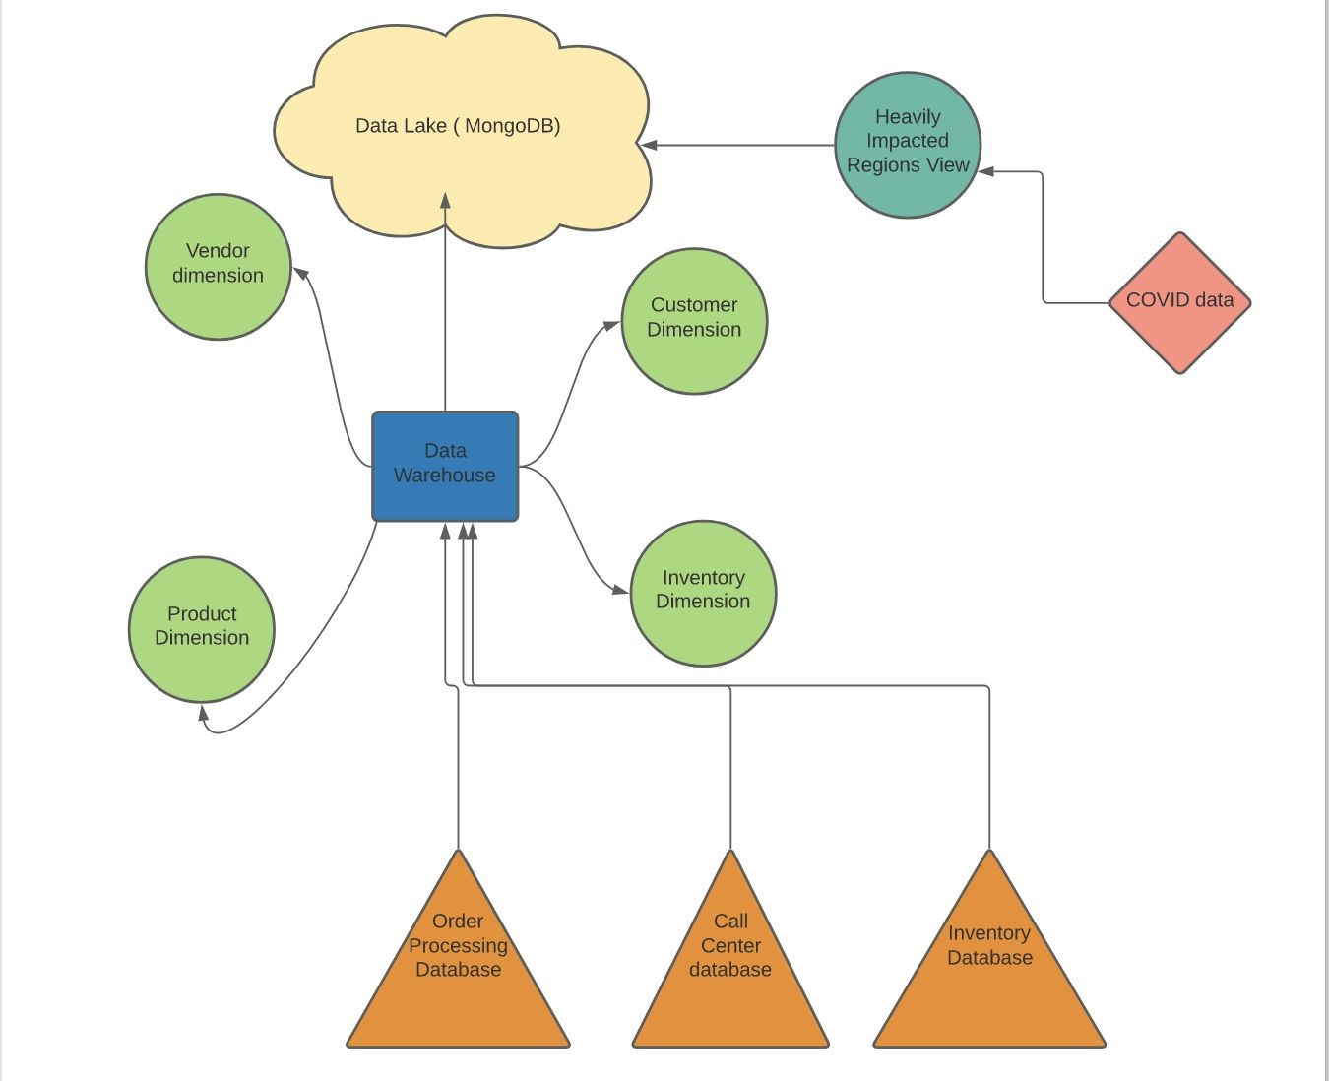

Section 5: Analytics Code for MongoDB Data Lake

Code :

[

{

"$group": {

"_id": {

"__alias_0": "$PRODUCT_ID"

},

"__alias_1": {

"$addToSet": "$CALL_ID"

}

}

},

{

"$project": {

"_id": 0,

"__alias_0": "$_id.__alias_0",

"__alias_1": {

"$size": "$__alias_1"

}

}

},

{

"$project": {

"x": "$__alias_1",

"y": "$__alias_0",

"_id": 0

}

},

{

"$addFields": {

"__agg_sum": {

"$sum": [

"$x"

]

}

}

},

{

"$sort": {

"__agg_sum": 1

}

},

{

"$project": {

"__agg_sum": 0

}

},

{

"$limit": 5000

}

]

Code for 2nd chart:

[

{

"$group": {

"_id": {

"__alias_0": "$COUNTRY_NAME"

},

"__alias_1": {

"$sum": {

"$cond": [

{

"$ne": [

{

"$type": "$VENDOR_CITY"

},

"missing"

]

},

1,

0

]

}

}

}

},

{

"$project": {

"_id": 0,

"__alias_0": "$_id.__alias_0",

"__alias_1": 1

}

},

{

"$project": {

"x": "$__alias_0",

"y": "$__alias_1",

"_id": 0

}

},

{

"$addFields": {

"__agg_sum": {

"$sum": [

"$y"

]

}

}

},

{

"$sort": {

"__agg_sum": -1

}

},

{

"$project": {

"__agg_sum": 0

}

},

{

"$limit": 5000

}

]

Code for 1st chart:

[

{

"$group": {

"_id": {

"__alias_0": "$COUNTRY_NAME"

},

"__alias_1": {

"$sum": {

"$cond": [

{

"$ne": [

{

"$type": "$VENDOR_CITY"

},

"missing"

]

},

1,

0

]

}

}

}

},

{

"$project": {

"_id": 0,

"__alias_0": "$_id.__alias_0",

"__alias_1": 1

}

},

{

"$project": {

"y": "$__alias_1",

"x": "$__alias_0",

"_id": 0

}

},

{

"$addFields": {

"__agg_sum": {

"$sum": [

"$y"

]

}

}

},

{

"$sort": {

"__agg_sum": -1

}

},

{

"$project": {

"__agg_sum": 0

}

},

{

"$limit": 5000

}

]

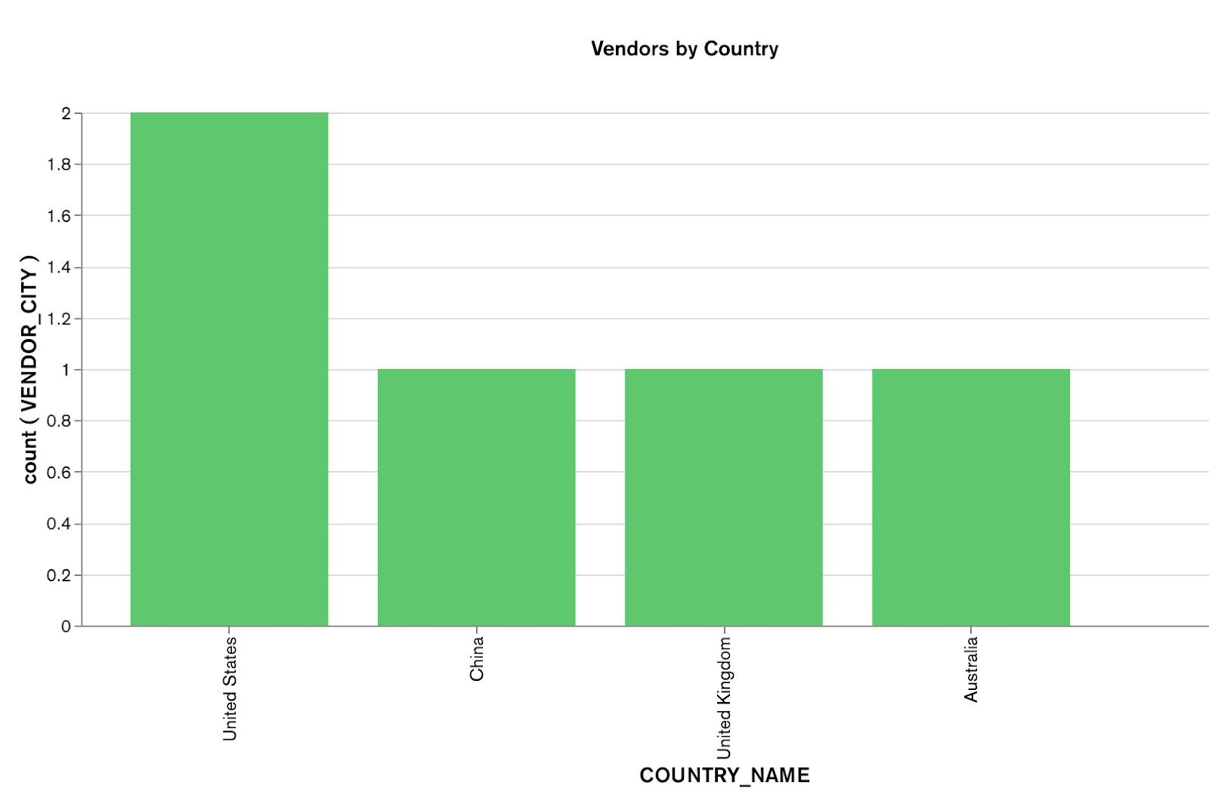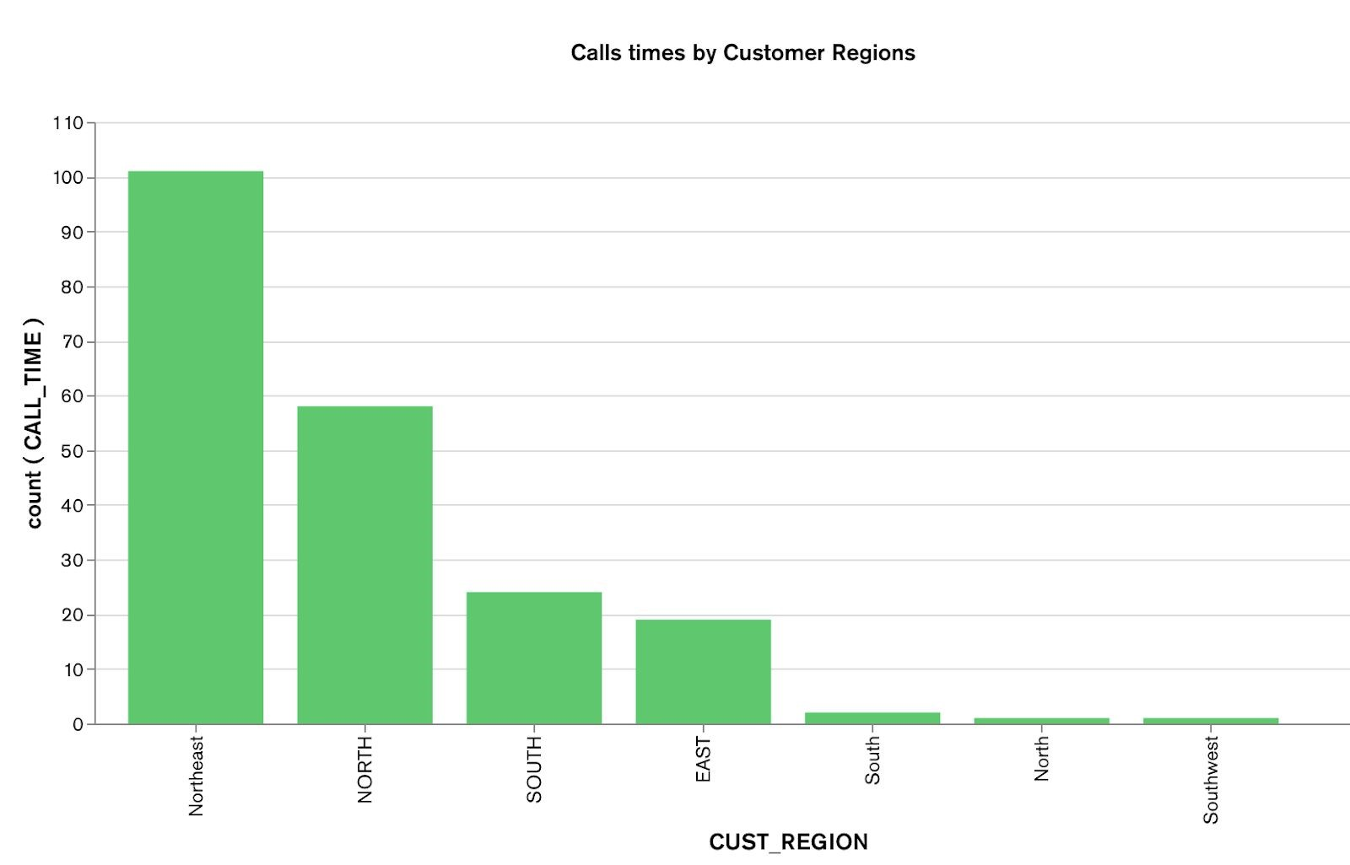

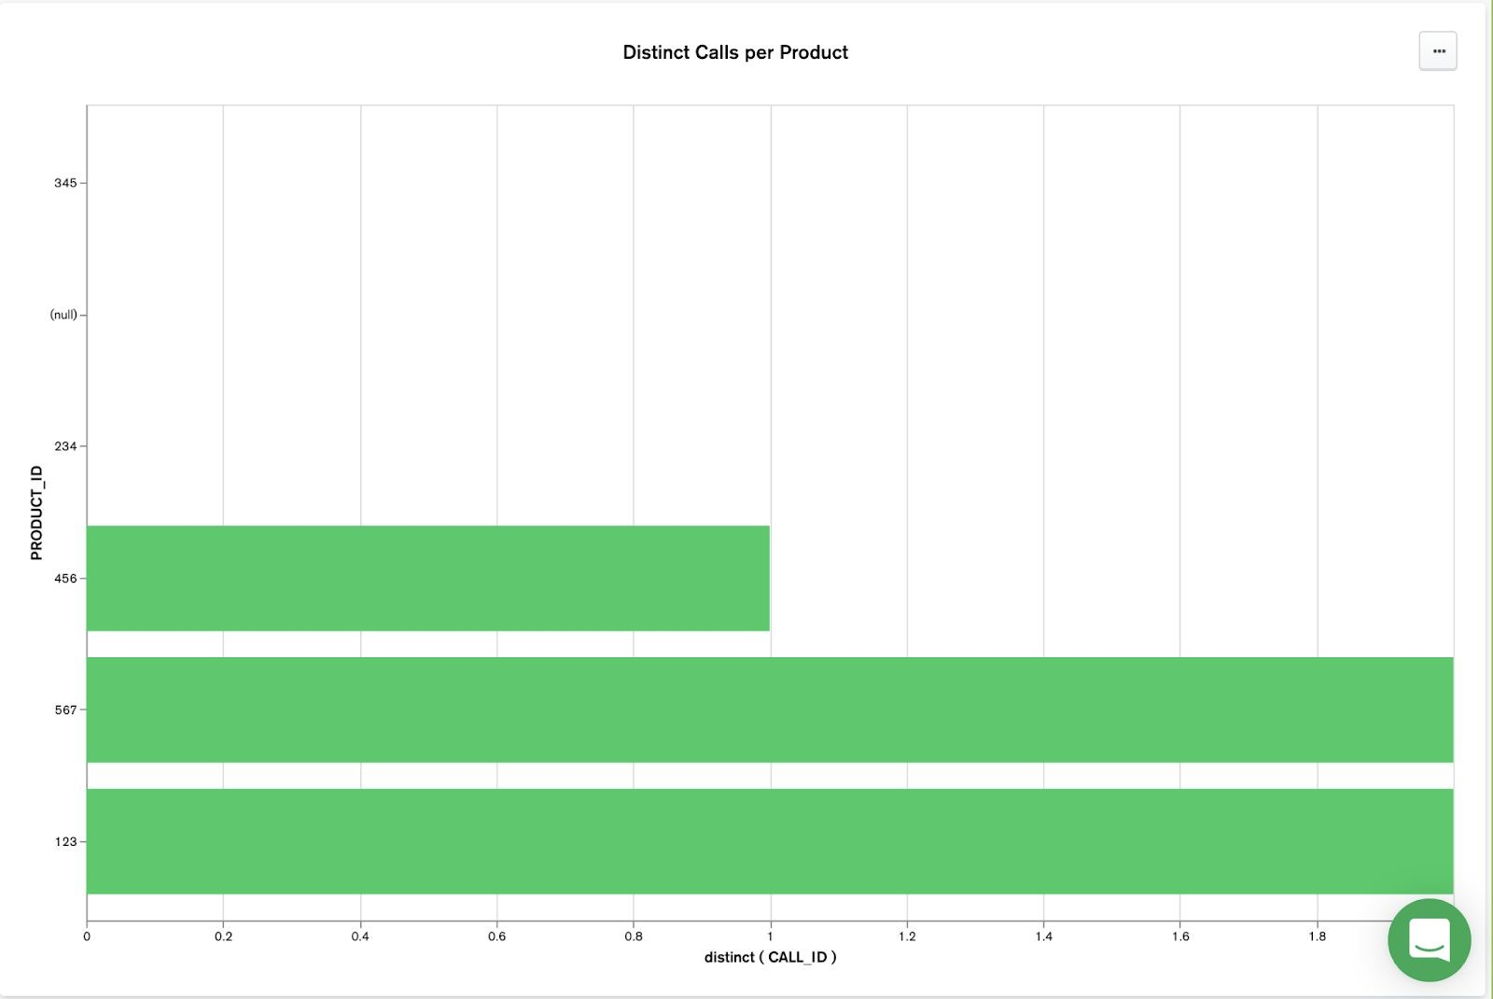

Analytics Code for Amazon S3 Data Lake

import pandas as pd

import matplotlib as plt

df1=pd.read_csv("Call.csv")

df2=pd.read_csv("Customer.csv")

df3=pd.read_csv("Order.csv")

df4=pd.read_csv("Product.csv")

df5=pd.read_csv("Supplier.csv")

df2['city'].value_counts().plot(kind='bar')

**Number of customers per city**

import seaborn as sns

import matplotlib.pyplot as plt

%matplotlib inline

ax=sns.histplot(binwidth=0.5, x="city", hue="prime_member", data=df2, stat="count", multiple="stack")

ax.set_xticklabels(df2['city'].tolist(), rotation=90, horizontalalignment='right')

**No. of Prime members per city**

**Relation between call length and customer satisfaction**

df1.plot(x='call_length', y='satisfaction', style='o')

df5=df4[df4["product_category"]=="Clothing"]

value_dict=dict()

value_dict["Clothing"]=df5["average_rating"].mean()

df5=df4[df4["product_category"]=="Kitchen"]

value_dict["Kitchen"]=df5["average_rating"].mean()

df5=df4[df4["product_category"]=="Electronics"]

value_dict["Electronics"]=df5["average_rating"].mean()

plt.bar(value_dict.keys(), value_dict.values(), color='g')

**Average rating for each product category**

df3['payment_type'].value_counts().plot(kind='bar')

**Number of customers using each payment method**

df5['state_province'].value_counts().plot(kind='bar')

**Number of suppliers per city**

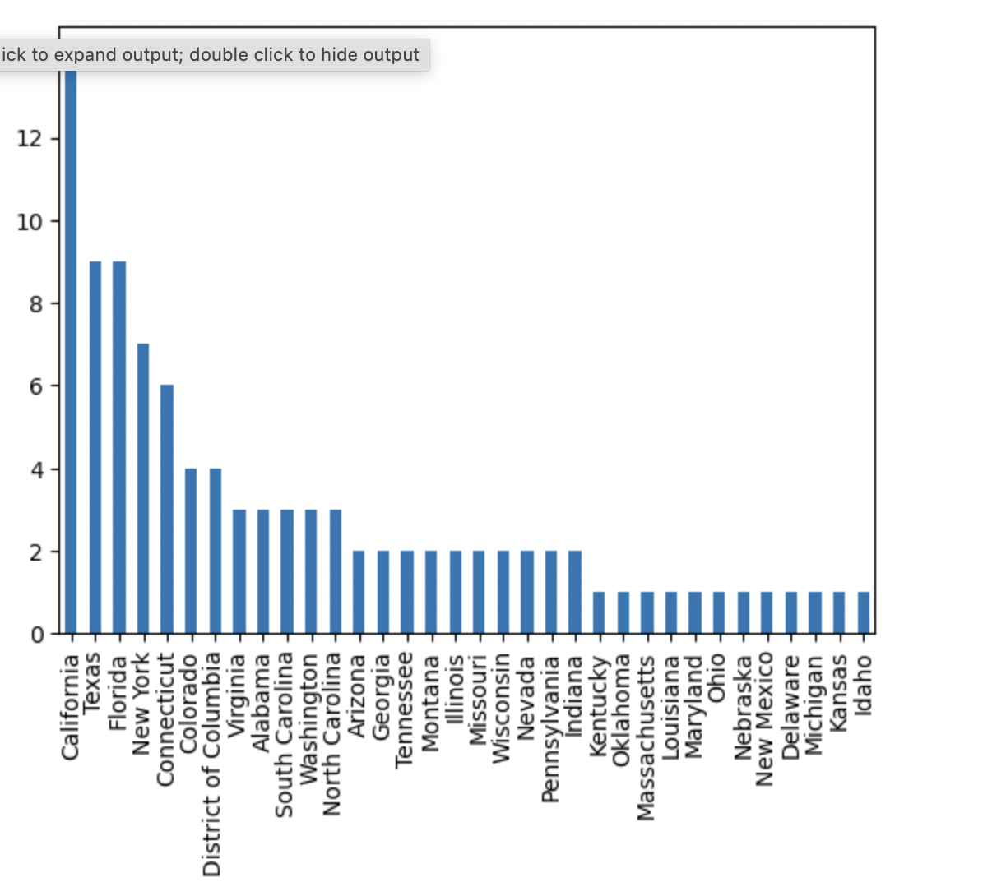

Supplementary Analysis on Transaction Tables in Oracle

1. Evaluating our shipping vendors by seeing how many of their deliveries aren’t on time:

SELECT Shipping_Vendor.shipping_vendor_name AS "Shipping Vendor", COUNT(Shipping_Vendor.shipping_vendor_id) AS "# Late Deliveries"

FROM Shipping_Vendor

INNER JOIN "Order"

ON Shipping_Vendor.shipping_vendor_id = "Order".shipping_vendor_id

INNER JOIN "Call"

ON "Order".order_id = "Call".order_id

WHERE "Call".problem_id=4

GROUP BY shipping_vendor_name;

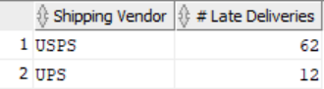

1. Looking into the most complained about products on customer service calls vs. online rating

SELECT Product.product_name AS "Product", COUNT(Product.product_id) AS "# Complaints", Product.average_rating AS "5-Star Rating"

FROM Product

INNER JOIN "Call"

ON Product.product_id = "Call".product_id

GROUP BY Product.product_id, Product.product_name, Product.average_rating

ORDER BY COUNT(Product.product_id) desc;

